# Preparing files for a ninjaCap build

Inputs to our ninjaCap framework are

1. a "probe.SD" file that describes the geometrical setup (as documented in the Homer2 toolbox) and the grommet types to be used. NOTE: For this you need the latest version of the AtlasViewer GUI (May 2020 or newer)
2. the desired headcircumference in cm.

Outputs of this code are four .stl files for 3D printing with ninjaflex.

## Create your "probe.SD" using the the SDgui of the latest version of AtlasViewer (May 2020 or newer) that you can find here:

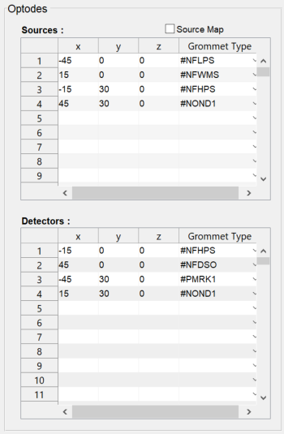https://github.com/BUNPC/AtlasViewer

For each source, detector AND dummy optode, select the Grommet Type of that optode. The Grommet Type is an identifier that is used in the cap generation to place the desired element (holder, grommet, …) at the position of the corresponding optode. The available types of grommets and their corresponding identifiers are given in the table on the next page. Selecting the type “#NONE” will skip the placement of an element for this optode. You can assign any Grommet Type identifier to any optode (source, detector, and dummy optodes)!

Please note for Short Separation (SS) Measurements: Depending on the type of grommet you choose, short separation channels (holes for a SS fiber) are typically already included. In your SD probe layout, you might have added dedicated SS optodes. If you did, just give those a “#NONE” ID to skip the placement of a dedicated element at the SS optode location.

Save that configuration under the name "probe" with the native ".SD" file extension under …\ninjaCap\userinput\probe.SD.

**If you want to add your own (custom) Grommet Type:**

STL files for these elements are placed under   
 …/ninjaCap/stl/elements/<identifier>/…

where <identifier> is the folder name identical to the defined string ID. Files within are always “grommet.stl” and “grommetComplement.stl”, where “grommet” is the element to be placed, and “grommetComplement” is the keep out geometry used to create corresponding holes/spaces in the panel grids. This compliment must be the same size as the needed gap in the pattern of the panel grids for the hole produced by the grommet. These “grommets” can have any geometry and can also be elements that are not “grommets” after all. If your grommet ID is not available in AtlasViewer, you can select any type and manually change them to your new custom ID by manually opening the SD file in matlab and changing the entries in the following three fields of SD struct: ‘SrcGrommetType’, ‘DetGrommetType’ and ‘DummyGrommetType’. When saving the STL for a new grommet you must ensure that the grommet is aligned on the X-Y plane as it’s bottom and the origin point for both the grommet and the compliment must be in the center of their hole for the optode to ensure correct grommet placement on the ninjaCap.

|  |  |  |  |
| --- | --- | --- | --- |
| **Identifier** | **Info** | **Image** | **Dimensions** |
| #NFLPS | **N**IRS: **F**iber-based optode holder (CW6 fibers) with **L**ow **P**rofile and single **S**hort-separation hole |  |  |
| #NFHPS | **N**IRS: **F**iber-based optode holder (CW6 fibers) with **H**igh **P**rofile and single **S**hort-separation hole |  |  |
| #NFWMS | **N**IRS: **F**iber-based **W**ide optode holder (CW6 fibers) with **M**ultiple **S**hort-separation holes |  | Inner radius: 03.4 mm Outer radius: 08.0 mm  Height: 02.0 mm  SS Distance: 08.0 mm SS radius: 0.90 mm |
| #NFDSO | **N**IRS: **F**iber-based **D**ual **S**s **O**ptode holder |  |  |
| #NOND1 | **N**IRS: **O**pen f**N**IRS **D**ual optode holder for optodes in printed case |  |  |
| #NOND2 | **NIRS: Open fNIRS dual optode holder for optodes in printed cases Rev AB and later** |  |  |
| #PMRK1 | **P**osition **M**a**RK**er in small cross shape, symmetric |  |  |
| #ACHLD | ninjaNIRS **Ac**celerometer **H**o**LD**er |  | 21 mm diameter  10 mm height |

Continued on the next page…

|  |  |  |  |
| --- | --- | --- | --- |
| #EBPAS  (currently N/A) | **E**EG electrode holder from **B**rain **P**roducts: **A**ctiCap **S**nap |  | C:\Users\avolu\AppData\Local\Microsoft\Windows\INetCache\Content.Word\I_ac_snap_top.png |
| #EECEH  (currently N/A) | **E**EG **E**asy **C**ap **E**lectrode **H**older:Ring for commercial electrode holders | Tbd | Tbd |
| #NONE | **Dummy** Optode, nothing placed | None | None |